Commentary >> Third Party Commentary >> Symposium Papers (CPA Canada Commodity Tax) >> 2006 (Ottawa, October 16-18) >> 9. Some Indirect Tax Consequences of the International Transfer of Intangible Property

SOME INDIRECT TAX CONSEQUENCES OF THE INTERNATIONAL TRANSFER OF INTANGIBLE PROPERTY
By: Craig Robertson, Associate Partner, Deloitte*
Lisa Zajko, Manager, Deloitte*

The Context - IPP can be transferred internationally between participants from different countries and/or used by the owner in many countries
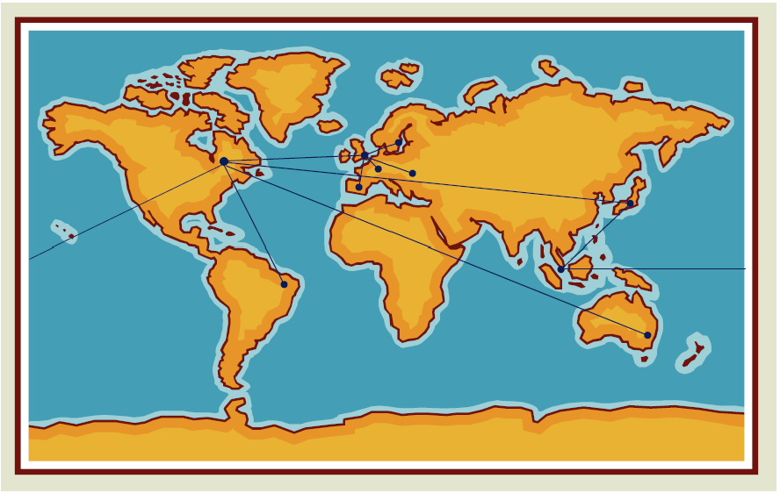

The Context - Convergence - Transfers globally
• Purpose - to warn about unrecognized
– Indirect tax costs
– Compliance problems/burden
– Potential undisclosed liability on the consolidated financial statements- need to ensure local indirect tax concerns are addressed
• Separate VAT/GST and Customs issues
– VAT - EU coordinated but other countries are not and even differences in EU
– Customs - WTO Valuation Agreement - binding under WTO and GATT
• Note - the purpose of this presentation is not to provide a technical analysis of VAT and Customs rules outside Canada, and instead is to share experiences that we have derived from our clients' international dealings relating to intangibles

VAT/GST
• VAT global policy
– Differences in requirements affecting IPP
– Generally should not allow for trapped VAT in the commercial activity
• Restricted recovery in some countries
• Compliance burden created by movement of IPP
• Increased tax burden when VAT not recovered
• Concerns relating to intangibles are being studied by OECD taskforces
– "The Application of Consumption Taxes to the Trade in International Services and Intangibles", OECD, 2004 - www.oecd.org
– Consumption Taxes: The International Trade in Services and Intangibles: A Note by the OECD Secretariat, March 2005

The International VAT Environment
• The Theoretical Framework - Achieve Taxation on Consumption (Ottawa Conference)
• Issues
– Standardization of what constitutes consumption in the case of intangibles
– Development of proxies for consumption
– Usually the "place of supply" rules
• Illustrations - what is consumption?
– Repair of a watch in one country, owner of watch resident of another country
– Movie star having hair styled in Toronto, traveling to Los Angeles for Gala Opening
– Company acquiring technological process from a manufacturer in Germany for use in operations in Canada, UK, Japan and Poland
– Different proxies have been developed for the different situations

The Theoretical Framework - Achieving Tax on Consumption

OECD Report - Problems, Causes and Remedies*
• Double and inappropriate taxation | • Unintentional non-taxable
• Lack of supply claim efficiency | • Inability to enter markets
• Distortion of competition | • High compliance costs
• Non-compliance | • Uncertainty

Not All Countries Allow Full Input VAT
• China
– General VAT rate 13%
– Only 9% VAT recovery on inputs into sales within China; restricted recovery on fixed assets
– Fuller recovery on inputs into sales outside China
• Costa Rica and Columbia
– Restricted VAT recovery
• Result
– Additional VAT cost, even on inputs to fully taxable supplies

Inbound and Outbound GST Issues

Difference between IP (specific) and IPP (generally)
• IPP - all intangibles
• IP - a subset of IPP
– literary, artistic and scientific works
– performances of performing artists, phonograms and broadcasts
– inventions in all fields of human endeavor
– scientific discoveries
– industrial designs
– trademarks, service marks and commercial names and designations
– protection against unfair competition
– and all other rights resulting from intellectual activity in the industrial, scientific, literary or artistic fields".:
[Source: The Convention Establishing the World Intellectual Property Organization (WIPO) (Stockholm, July 14, 1967)- WIPO Intellectual Property Handbook: Policy, Law and Use (Second Edition), WIPO 2004 Geneva]
• IPP that is not IP
– Access codes to a downloaded program
– Customer lists
– Goodwill of a business
– Distribution rights
• CRA's conclusion: Although these may be IP components in some IPP (e.g. distribution rights or franchise rights) this does not mean they are IP per se
• But Dawn's Place (TCC 2005 - under appeal) - access to a website's content is "IP" as being a right to use copyright

Canadian GST - Outbound IPP Concerns
• Place of supply rules - 142(1)(c) versus 142(2)(c)(i)
– Whether IPP may be used in Canada
• Limited scope of zero-rating rule in Section 10
– "supply of an invention, patent, trade secret, trade-mark, trade-name, copyright, industrial design or other intellectual property where the recipient is a non-resident who is not registered..."
• Distribution rights granted by a GST registrant
– May be subject to GST and not zero-rated
– Must be addressed in the distribution agreement: include clause that the rights "may not be used in Canada"

EU VAT - 6th Directive - Place of Supply - Characterization
• "Supplies of Goods" - "the transfer of the right to dispose of tangible property as owner"
• "Service" - anything that is not tangible personal property
• The Levob Verzekerengen case (European Court of Justice Oct. 27, 2005):
– Issue of characterization : "goods" or "service"
– Software together with customizing services acquired outside the Netherlands
– If the customizing services were "goods", no requirement to self-assess Netherlands VAT
– If "service", obligation to self-assess
– The Levob insurance group is subject to restricted VAT recovery
– Decision : the customizing services were not "goods" under the Sixth Directive and self-assessment of Netherlands VAT was required

The International Matrix - Contrasting Canadian GST and EU VAT

Place of supply rules
• Canada
– Sale of Goods: 142(1)(a) and 142(2)(a) - place of delivery
– IPP 142(1)(c) and 142(2)(c) - where can the IPP be used?
– 143(1) "carry on business" override"
• EU
– 6th Directive - IPP usually a service
– Services normally deemed supplied at the established place of business of the recipient
– Goods - normally deemed supplied at the place of business of the supplier
• Canada
– Zero-rating rule
– s. 10 for IP proper
– No rebates for IPP [or for goods since September 26, 2006 announcement]
• EU
– no zero-rating rule
– Possible refund under 13th Directive
– Strict timing and procedural requirements
– Reciprocity rule - rebate available in country x to resident of Country Y if country Y gives a reciprocal rebate
– Recovery of cross-border VAT in the EU estimated at 50%!

Self-Assessment Regime
• Canada - Division IV usually applicable where the IPP is not for use in CA
– Even if use in CA is very high (e.g. 99%), still have to self-assess and claim ITC
• EU and elsewhere - self-assess in all cases - claim input VAT
– Compliance obligation often very high requirement to match periods carefully
– Example : Poland VAT control
– Royalty charge dated June 2006 (supplier is not established in Poland)
– Polish recipient self-assesses August 2006, and claims offsetting input VAT
– Risk (per experience of our Warsaw office)
– VAT Authority will assess VAT not self-assessed in June 2006, without credit for input in the same period [no obligation to "assess to net tax"]
– VAT Authority will deny input VAT incorrectly claimed in August 2006

Self-Assessment Regimes - Global Operations - Potential Obligations and Liabilities
• Requirement to recognize license fees/royalties attributable to a particular country
• Some countries require strict matching of reporting obligations by reporting period
– Report VAT payable
– Claim offsetting input VAT
– Input VAT may not be allowed if not claimed in the correct period (Polish VAT administration)
– Penalties for non-compliance

Self-Assessment Regimes - Global Operations - Potential Obligations and Liabilities to recognize license fees/royalties attributable to a particular country
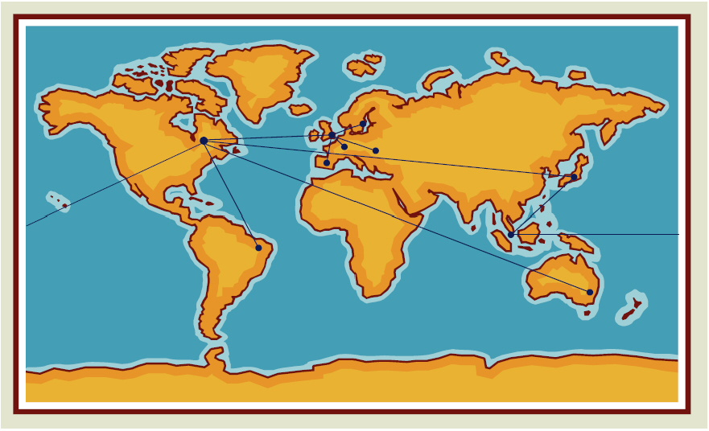

Incidence of Multiple VAT - Value for Duty
• GST/VAT applies on the value of goods for duty
– Customs value for duty includes royalties, "assists", other
• Royalty agreement may also attract GST/VAT
– Self-assessment (e.g. Division IV)
– Supplier must collect
• Possibility of multiple tax across different countries
– Value of "assists" included in value for duty in multiple countries
Example - Goods Imported into Germany
• Sale Price of Imported Goods | $10,000,000 EU
• Licensing fee (applicable to the goods) | 500,000 EU
 | $10,500,000 EU
• VAT @ 16%* | $ 1,680,000 EU
• Licensing fee also subject to self-assessment | 500,000 EU
• VAT @ 16% | 80,000 EU

Inbound GST - Multiple Tax due to Self-Assessment
• "Purchased Software" - per TIB B-037R - value of software and physical medium is subject to GST under Division III
– Custom value may include "license fees" or other service fees
• Division IV self-assessment obligations may also apply on the continuing license fees or service fees
• Result - potential double-taxation and GST may be unrecoverable

Customs Duties and IPP
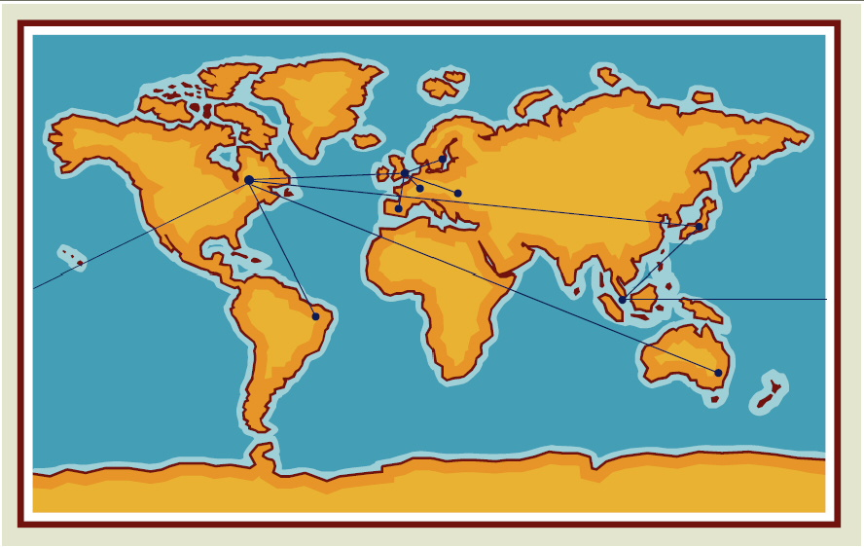

Outline: Customs Duties and IPP
Goods Embodying an Element of IPP
– Price Paid or Payable ("PPP")
– Adjustments to the Price Paid or Payable
– Royalties
– Assists
– Payments Which May Constitute Both a Royalty and an Assist
– Subsequent Proceeds
• Importations of IPP Itself
– Software
– Information Based Products
• Customs Enforcement
• Administrative Penalties

Introduction: Customs Duties and IPP
• Customs duties apply to "goods", not information
• The value of IPP can, in some instances, form part of the customs value of an imported good
• International trading community has striven to achieve consistency in customs valuation through the Agreement on Implementation of Article VII of the General Agreement on Tariffs and Trade 1994
• Varying interpretations and domestic implementations can result in complications and differing treatment
• Discussion focuses on
– (i) goods embodying an element of IPP
– Elements of transaction value that may capture the value of IPP
– (ii) importations of IPP transported on a physical carrier medium

Price Paid or Payable ("PPP")
• Definition: the aggregate of all payments made or to be made, directly or indirectly, in respect of the goods, by the purchaser to, or for the benefit of, the vendor
• How broad should the phrase "to, or for the benefit of, the vendor" be interpreted?
– Charley Originals Ltd. - FCA determined that the CBSA had construed the word "benefit" too broadly
– Consider: Contractual obligations of the parties
– U.S. CBP HQ Rulings
– Quota payments to 3rd parties unrelated to the vendor are not included in the PPP
– Re-characterization of who the vendor is where a 3rd party shipper has been nominated for quota purposes
• Bundled vs. Unbundled Pricing
– Eg. Royalties and Licence Fees as an Element of PPP?
– D13-4-9
– Amounts included in the invoice price and not separately identified are part of PPP
– No relevant deduction provisions once amounts are included in PPP
– U.S. Approach Extends Beyond "Bundling"
– Generra Sportswear Co.: All payments made by a purchaser to a vendor are presumed to be included in PPP
– Also includes all payments made to a party related to the vendor
– Chrysler Corporation: Presumption rebutted when the payment is shown to be unrelated to the imported goods

Royalties
• Royalties and licence fees, including payments for patents, trade-marks and copyrights
– in respect of the goods
– the purchaser of the goods must pay directly or indirectly
– as a condition of the sale of the goods for export to Canada
– exclusive of charges for the right to reproduce the goods in Canada
• "Condition of Sale" - strict interpretation such that vendor must be entitled to refuse to sell or repudiate sale for non-payment
– Mattel Canada Inc. - Vendor and Licensor Separate Parties
– Reebok Canada Inc. - Extended to Same Party Vendor/Licensor
• CBSA Continuing to Review and Assess Royalty Payments!

Assists
• Value of certain goods and services supplied
– Directly or indirectly
– By the purchaser of the goods
– Free of charge or at a reduced rate
– For use in connection with production and sale for export of goods
– Apportioned in a reasonable manner and according to GAAP
• Relevant "Assists" in Relation to IPP
– (ii) Tools, dies, moulds utilized in the production of imported goods
– (iv) Engineering, development work, art work, design work, plans and sketches undertaken elsewhere than in Canada and necessary for the production of the imported goods
• Direct vs. Indirect Supplies
– Example: Corporate contributions to R&D
– 48(5)(a)(iii) - "The value of any of the following goods and services...that are supplied, directly or indirectly, by the purchaser... for use in connection with the production and sale for export of the imported goods...."
– Is there a direct link between corporate contributions to R&D and the importation of specific goods?
• Determining the Appropriate Assist Amount
– "Research" is not specifically enumerated under type (iv) category
– Challenges with respect to segregating research from development
– Concept of "pure research"
– CBSA - inclusion of R&D in PPP, Assist, and Subsequent Proceeds - research only to be excluded for Assists
– Data and information, including computer software: necessary for the production of the imported goods?
• Design and Development Costs (D&D)
– Interaction between type (ii) and type (iv) - domestic D&D provided to foreign manufacturer is excluded as an assist but may be included in the value of a mould that is produced and supplied to the vendor
– Prototypes - if determined to be a mould or similar good under (ii), duties are paid on D&D costs in country of production and on same value in country of importation for finished goods
– U.S. Rulings consider whether the prototype is "used" in the production
• Apportionment
– WTO Agreement and Valuation for Duty Regulations direct that the value, once determined, is apportioned over the imported goods
– Appears to be no provision to apportion over all goods produced but not necessarily imported
– U.S. - apportion where production is partially for export to the U.S. or if the assist is used in more than one country

Payments Which May Constitute Both a Royalty/Licence Fee and an Assist
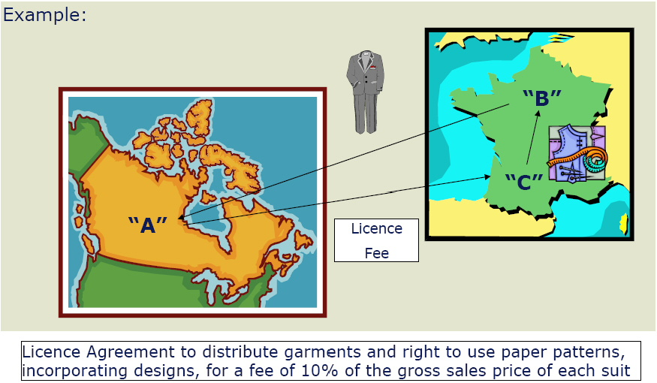
• Importations where the Canadian purchaser makes a payment for design work to be provided abroad and that work is necessary for the production of the imported goods
• Customs Departmental Memorandum D13-4-9 - Royalties
– Appendix A, Example 4 - 5% of payment is for the use of the licensor's label and 5% is for design specifications, etc., supplied by licensor to manufacturer
– VPU - CBSA HQ - importer to demonstrate reasonable apportionment between payment for right to distribute and payment for design work; otherwise, entire amount may be captured under the assist provision
• WTO Technical Committee on Customs Valuation
– Additional payment to be included in the Customs value of imported goods under the terms of the assist provision
– Not necessary to consider inclusion under the royalty provision
– Licence fee to be treated as the payment for an assist

Subsequent Proceeds
• The value of any part of the proceeds of any subsequent resale, disposal, or use of the goods by the purchaser thereof that accrues or is to accrue, directly or indirectly, to the vendor
• Tangible goods versus intangible rights
– Mattel - No need to consider a royalty or licence fee under the subsequent proceeds provision as this would render the restrictive language of the royalty provision meaningless
– Payment is for the goods and not a related intangible right
– Management Fees - historical attempt to capture these fees, or at least the excessive portion
• Distinction Between PPP and Subsequent Proceeds

Importations of IPP Itself
• Software
– Distinction Among Various Countries in Adopting Decision 4.1
– Computer Carrier Media Remission Order
• Information Based Products
– D13-11-2
– Eg. Television Commercial - production costs vs. cost of medium and transcribing information
– Airline Tickets, Bank Notes - Customs Notice CN-605; Gift Cards
– Payment for an airline ticket is for the future right to travel; value based on cost of the paper and printing
– Value of bank notes is based on the paper and not the denomination
– Gift cards - VPU has advised that the dollar value of the card may be included in customs value if the cards have been sold at a price inclusive of that amount

Customs Enforcement
• Protection of IP Rights in the Context of Free Trade
– Negotiation of the NAFTA
– Enforcement Responsibilities of Customs Officials
– Canada, the U.S., and Mexico
– Implementation Issues

Administrative Penalties
• Canada
– Penalties under the Administrative Monetary Penalty System ("AMPS")
– Penalties for Incorrect Value
– C083 (Non Revenue)
– C353 (Revenue)
– Non-dutiable goods - revenue or non-revenue when Division III GST is applicable?
• U.S.
– Dutiable Goods
– maximum: 2 times or 4 times the total loss of duties, taxes, and fees (negligence and gross negligence) up to domestic value (fraud)
– Mitigated: 0.5 times to 8 times total duty loss (including fees) but not to exceed domestic value
– Non-Dutiable Goods
– Maximum: 20% of value (negligence), 40% of value (gross negligence), or domestic value (fraud)
– Mitigated: 5% to 80% of domestic value

Footnotes
* Deloitte, Canada's leading professional services firm, provides audit, tax, financial advisory services and consulting through more than 6,600 people in more than 46 offices. Deloitte operates in Québec as Samson Bélair/Deloitte & Touche s.e.n.c.r.l. The firm is dedicated to helping its clients and its people excel. Deloitte is the only professional services firm to be named to the Globe and Mail's Report on Business magazine annual ranking of Canada's top employers for two consecutive years: 35 Best Companies to Work for in Canada in 2001 and 50 Best Companies to Work for in Canada in 2002. "Deloitte" refers to Deloitte & Touche LLP and affiliated entities. Deloitte is the Canadian member firm of Deloitte Touche Tohmatsu. Deloitte Touche Tohmatsu is a Swiss Verein (association), and, as such, neither Deloitte Touche Tohmatsu nor any of its member firms has any liability for each other's acts or omissions. Each of the member firms is a separate and independent legal entity operating under the name "Deloitte", "Deloitte & Touche", "Deloitte Touche Tohmatsu" or other related names. The services described herein are provided by the Canadian member firm and not by the Deloitte Touche Tohmatsu Verein.
* Deloitte, Canada's leading professional services firm, provides audit, tax, financial advisory services and consulting through more than 6,600 people in more than 46 offices. Deloitte operates in Québec as Samson Bélair/Deloitte & Touche s.e.n.c.r.l. The firm is dedicated to helping its clients and its people excel. Deloitte is the only professional services firm to be named to the Globe and Mail's Report on Business magazine annual ranking of Canada's top employers for two consecutive years: 35 Best Companies to Work for in Canada in 2001 and 50 Best Companies to Work for in Canada in 2002. "Deloitte" refers to Deloitte & Touche LLP and affiliated entities. Deloitte is the Canadian member firm of Deloitte Touche Tohmatsu. Deloitte Touche Tohmatsu is a Swiss Verein (association), and, as such, neither Deloitte Touche Tohmatsu nor any of its member firms has any liability for each other's acts or omissions. Each of the member firms is a separate and independent legal entity operating under the name "Deloitte", "Deloitte & Touche", "Deloitte Touche Tohmatsu" or other related names. The services described herein are provided by the Canadian member firm and not by the Deloitte Touche Tohmatsu Verein.
* OECD - The Application of Consumption Taxes to International Trade in Services and Intangibles - Progress Report and Draft Principles -www.oecd.org
* The German VAT rate will rise to 19% January 2007.

View Terms and Conditions and Privacy Policy
Help desk: Mon-Fri, 9am-5pm ET 1-866-256-6842 Contact Us
© 2001-2024, EYEP and/or E&Y LLP and/or CPA Canada. All rights reserved.

